Tarea 2 Vectores
MATEMÁTICAS Y ESTADÍSTICA PARA INTELIGENCIA ARTIFICIAL
Carlos Ramírez Martínez
2025
Vectors (fundamentals)
I - Position Vectors 2D
Using the applet below ﻿
a) Move F so that it has position Vector (2,1). ﻿
b) Move D so that it has position vector (-4,3). ﻿
c) Place the ends of the blue vector so that it becomes vector FD:
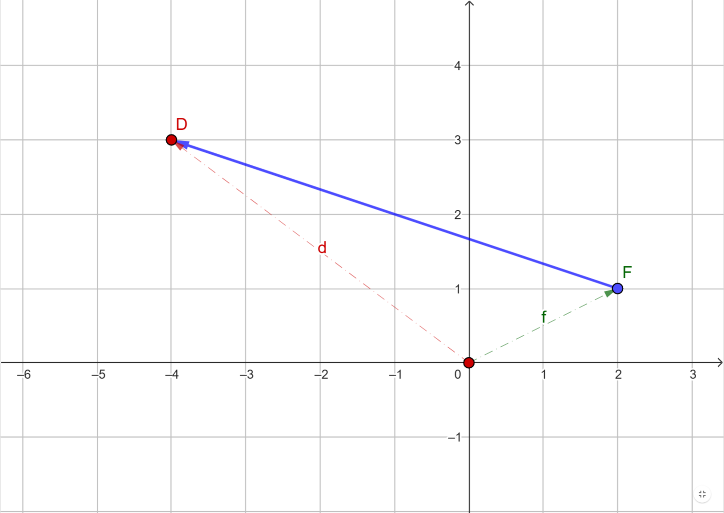
﻿d) State the components of FD.
$$f=OF=\left(2, 1\right)$$
$$d=OD=\left(-4, 3\right)$$
$$fd=FD=\left(-4-2, 3-1\right)=\left(-6, 2\right)$$
﻿e) State FD in terms of vectors f and d.
$$fd=FD=d-f$$

f-d = -2+4, 1-3, 2, -2
II- Vector Journeys 2D
Using the applet below
$u_{1}=u$ and $v_{1}= v$, move $u_{1}$ and $v_{1}$ about to help you visualise and answer the questions below. In terms of $u$ and $v$ state:
a) AB = $u$
b) BC = $v$
c) AD = $v$
d) CD = $-u$
e) AC = $u+v$
f) DB = $u-v$

III- Position Vectors 3D
Using the applet above
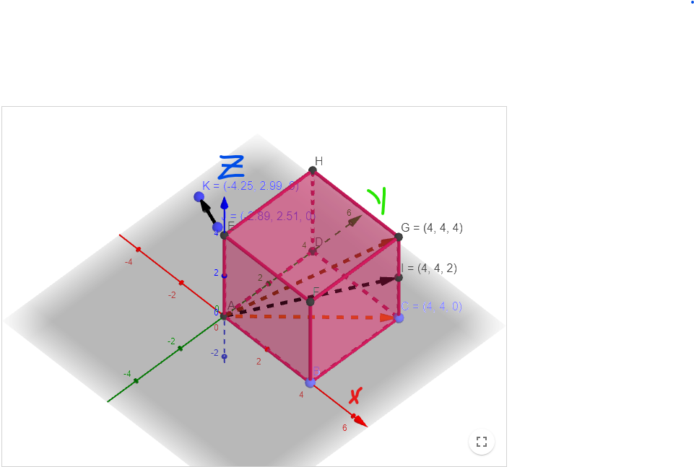
- ﻿List the coordinates of Points A,B,C,D,E,F,G,H,I. Notice that point A and O are the same. ﻿
O = A = (0, 0, 0)
B = (4, 0, 0)
C = (4, 4, 0)
D = (0, 4, 0)
E = (0, 0, 4)
F = (4, 0, 4)
G = (4, 4, 4)
H = (0, 4, 4)
I = (4, 4, 2)
- State: ﻿
- ﻿the components of ﻿ ﻿
$$OH=AH=\left(0-0, 4-0, 4-0\right)=(0, 4, 4)$$

- the components of ﻿
$AC=\left(4-0, 4-0, 0-0\right)=(4, 4, 0)$
- ﻿the vector in terms of vectors and . ﻿ ﻿
$$OB=\left(4-0, 0-0,0-0\right)=\left(4, 0, 0\right)$$
$$OG=\left(4-0, 4-0,4-0\right)=\left(4, 4, 4\right)$$
$$BG=\left(4-4, 4-0,4-0\right)=(0, 4, 4)$$
- the components of ﻿ ﻿
$$EI=\left(4-0, 4-0,2-4\right)=(4, 4, -2)$$
- the vector in terms of ﻿ ﻿
$$IE=\left(0-4, 0-4,4-2\right)=(-4, -4, 2)$$
- the components of
$$JK=\left(-4.25-\left(-2.89\right), 2.99-2.51, 0-0 \right)=(-1.36, 0.48, 0)$$

